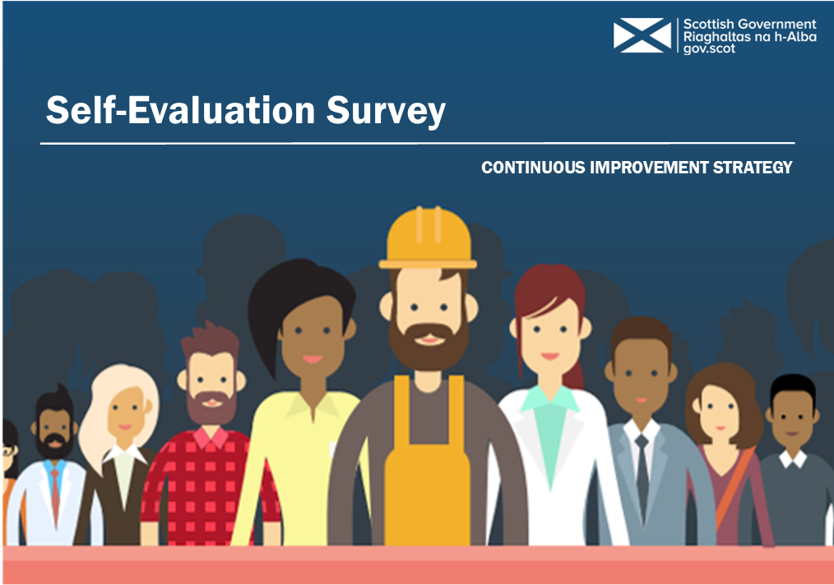
Standard | Evaluation
Input any relevant service standards or strategic objectives for your area below | Provide details of existing good practice | Provide details of where this could be improved

Following the assessment, use this section below to identify your top 5 areas for improvement
1.
2.
3.
4.
5.

